# Camera Resolution: Where Many Phone Buyers Go Wrong

When buying a phone, many buyers check the camera resolution before any other feature. But the camera resolution, which is vaunted by most phone manufacturers, doesn’t tell the whole story. This article will explain camera resolution - measured in [megapixels](https://www.supertekmodule.com/what-is-mega-pixel-in-camera/)(MP) - and why a high MP count alone doesn't translate into good pictures. Ultimately, we provide a guide on important considerations when buying a good camera smartphone that captures high-quality photos. Let's jump right in.

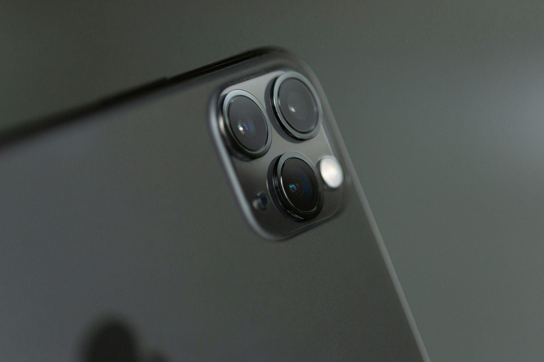

## What Are Megapixels?

A pixel is the basic unit of a digital image. A megapixel comprises a million pixels. So, a 64 MP camera captures an image with 64 million pixels.

So, does megapixel mean better, more detailed, and sharper photos? Here is the answer. The myriad pixels won't make any difference if the central sensor and lens aren’t at par.

## Enter the Sensor

The sensor matters more than a megapixel in terms of image quality. Why? It captures light and translates it into images. Large sensors allow more light to enter. As a result, you get enhanced dynamic range, sharper details, and better low-light performance.

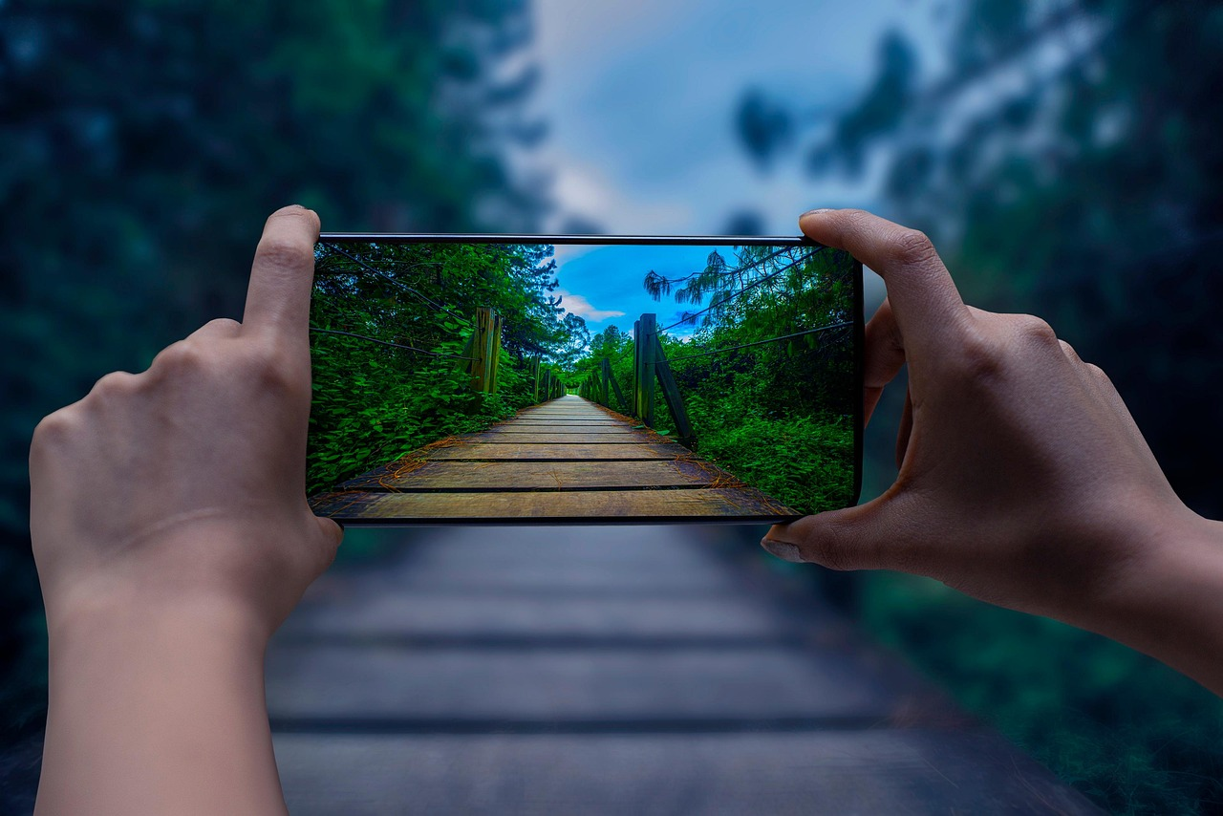

Premium smartphone brands like Samsung and iPhone have optimised sensors to complement their massive megapixel count. Similarly, even with a lower megapixel count, [Google Pixel](https://www.apicalhz.com/product/21) uses advanced algorithms for computational photography. As a result, the images are much better.

A well-optimised camera beats a high megapixel any day. A bigger sensor accommodates more pixels without sacrificing light sensitivity.

Some smartphone cameras with high megapixel counts produce low-quality photos that are overly sharp or give AI photos vibes.

Therefore, whether you are buying new or [used smartphones](https://www.apicalhz.com/blog/used%20smartphones%20in%20Kenya), prioritize big sensors.

## Don’t Forget the Aperture (F-Stops)

The aperture is another vital consideration when choosing a phone with a good camera. It works like an eye pupil. You can enlarge or shrink the size to allow more or less light to reach the camera sensor.

When the aperture is wide, it allows more light and vice versa. In other words, the extremes give sharper or blurred photos.

Ideally, you should check the f-stop. Pay attention here. Small numbers represent larger apertures. So f/2 has larger apertures than f/16. So it takes brighter photos and has better low-light performance.

So, if you are wondering which smartphone has the best camera, you now know. It is the smartphone with the lowest f-stop number.

## Does the Smartphone Resolution Matter?

Imagine having a massive canvas, but your brushes are worn out? The extra space won’t mean much. Similarly, the number of megapixels won't solely determine the color accuracy, image sharpness and overall photo quality.

So don't fall for the 200 megapixel camera phone myth. Usually, the manufacturers use [pixel binning](https://www.androidauthority.com/what-is-pixel-binning-966179/). This technique combines pixels into one to enhance performance in low light. The final photo is downsampled to a reasonable size, like 50 MP. So your phone will balance file size and quality rather than giving you a 200 MP image.

## Don’t disregard MP altogether!

While megapixels don’t give the full picture of the photos you can expect, they matter a lot. High megapixel count helps, especially when editing the photos. It allows cropping images while maintaining the detail and printing a large-sized photo. If you are looking for the [best deal on smartphones](https://www.apicalhz.com/blog/used%20smartphones%20in%20Kenya), always keep this fact in mind.

## Final Word: Go For a Balanced Smartphone Camera

In a nutshell, several factors determine the quality of a camera. On the hardware part, consider sensor size and lens aperture. Also, ensure the device has advanced software with a photo processing algorithm for scene detection, color correction, and image sharpening. With proper due diligence, you will choose a smart that captures eye-popping photos for posterity.